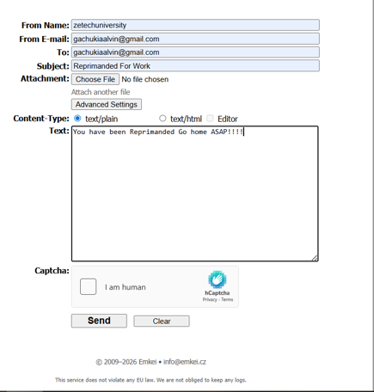

This is an example of a fake email being sent to a teacher on showing that the someone has been reprimanded by the school. It shows how one sends the information using the browser and key in the documents that are fake such as the email sender, but has the correct senders address.
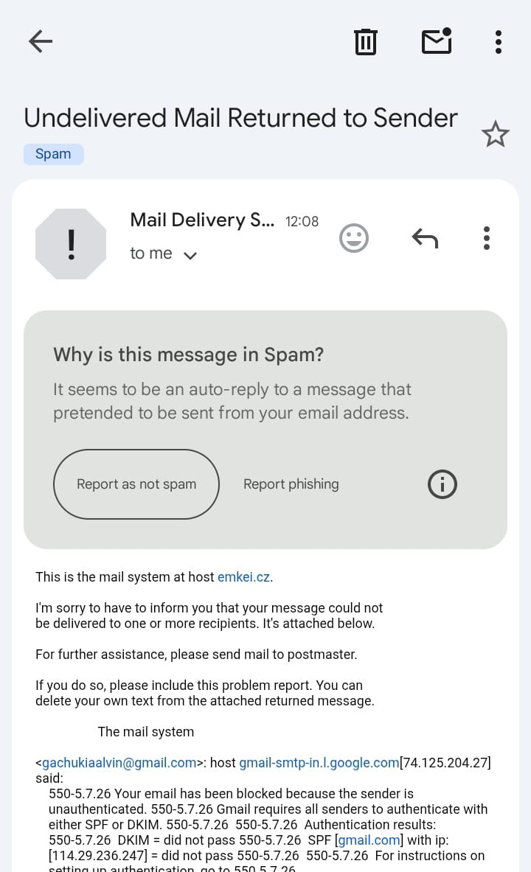

This is the mail after being sent to the recipient and it clears out the form on the users sides of the fake email and it goes to the recipient and displays the information on the spam due too the integrity of the security system. It shows that someone tried to send but that email was a fake one thus it was flagged by the Email system and it was sent to the spam.

